OSPI School Improvement Plan for 2021-2022

(and End-of-Year Improvement Plan Review for School Year 2020-21)

(Corresponds to Sections 15c, 16b, 17a, and 17b of the OSPI Consolidated School Improvement Plan Template)
For guidance on completing Sections I, II, & III below, please refer to the
SY 2021-2022 School Improvement Plan Template Implementation Guide.

Section I. End-of-Year School Improvement Plan Review for School year 2020-21

This section will serve as a summative evaluation of SY 2020-2021 goals, activities, measures, and results. Please, use Sections 13, 15a, 15b, and 16a of OSSI’s Consolidated Improvement Plan Template—or comparable sections if using your own custom SIP form—for reference in reflecting on your implementation and results.

Note: For schools operating a Title I, Part A, Targeted Assistance Program do not forget to progress monitor the effectiveness of your goals and activities supporting the targeted student population.

Building Data: Please provide your school district, building name, and date of submission of this template to OSSI’s SharePoint if applicable below.

School District Name:  Toppenish | Building Name:  Kirkwood Elementary School | Date of Submission to OSSI SharePoint (if applicable):  June 18, 2021

SY 2020-2021 High-Priority Goal #1: By 2021, Kirkwood Elementary will decrease the number of Tier III students for both ELA and Math by 15% through the use of the MTSS framework, strengthening Tier I supports in the core curriculum, development of high functioning PLCs, and the use of progress monitoring rubrics. We will use i-Ready diagnostic assessment, Oral Reading Records, WA Kids data, and classroom based formative assessments as applicable in each grade level.

Activities: Choose and describe two high-leverage activities implemented or tested related to achieving the stated high-priority goal above. | Measures: How did you analyze and evaluate? Please list and describe the tools you used to measure progress towards achieving your high-priority goal. Why were these tools appropriate? | Results/Progress: Please describe your results and progress so far in one to two sentences, i.e., what did you find in your data and what did it mean? (Paste hyperlinks in the space below to relevant documents if necessary.)
1)Kirkwood Elementary School analyzed the results from the September and October administration of the i-Ready assessment to determine our Tier III students in both reading and math. We identified 74 students grades K-5 for Tier III interventions based on the data. instructional need. Parents were contacted by phone in December 2020 to discuss participation in a new program we are offering in Toppenish SD (Pre-12) called Wildcat Academy 2021. | Student scores were sorted by domain and greatest instructional need. Wildcat Academy began January 29, 2021. It provided 13 days of focused instruction with progress monitoring throughout. A total of 45.5 hours of focused instruction was provided to students based on identified needs in phonics and place value. Research based interventions will be utilized to accelerate learning. Data chats took place with all students as they review their results from 2 diagnostic assessments and form personal goals. In April, students took part in a growth monitoring assessment to determine any needed adjustments. Throughout all 13 sessions, progress monitoring took place with a final diagnostic administered in late May to early June 2021. Final reports will be prepared on June 11, 2021 to summarize student growth. Time will be provided to reflect on the program and make recommendations for adjustments for the 2020-2021 school year. | 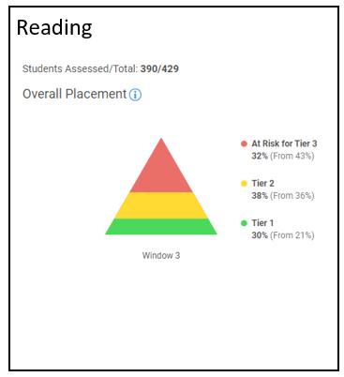  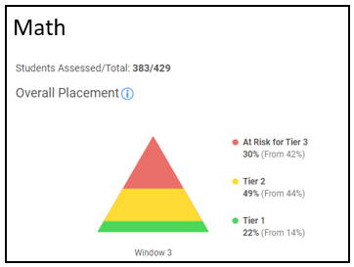
2)Continued ongoing professional development in strengthening Tier I and II instruction based on best practices in ELL | Staff attended professional development focused on ELL strategies to support teachers in a supportive mainstream program model. Teachers learned about academic language scaffolding and how to bridge and build content language. Furthermore, staff learned strategies to create effective student to student discourse: Question and Response Stems tied to Learning and Language Targets and Success Criteria. | Staff reflections and exit tickets demonstrated a deeper understanding in explicit instruction for language development. Staff implemented teaching practices that included an increase in student to student discourse using academic vocabulary.

SY 2020-2021 High-Priority Goal #2: By 2021, Kirkwood Elementary will decrease the number of students receiving Tier III interventions by 15% as measured by ongoing data collection of incidents and school/community climate surveys. We will achieve this through the strengthening of school wide Tier I supports (PBIS, Restorative Justice Practices, increase Family and Student voice and engagement, universal design for learning, and the development of culturally responsive pedagogy).

Activities: Choose and describe two high-leverage activities implemented or tested related to achieving the stated high-priority goal above. | Measures: How did you analyze and evaluate? Please list and describe the tools you used to measure progress towards achieving your high-priority goal. Why were these tools appropriate? | Results/Progress: Please describe your results and progress so far in one to two sentences, i.e., what did you find in your data and what did it mean? (Paste hyperlinks in the space below to relevant documents if necessary.)
1)Our PBIS team reviewed the TFI results from the 19-20 school year and presented the results to the staff in October 2020. Action steps were formed based on the Tier I implementation score from 2019-2020. | We re-evaluated our progress in May 2021 through the use of the same tool (TFI). We found this to be most useful in identifying deficits within our PBIS. | Our last TFI reported an implementation score of 53%. Our recent results yielded a 73% implementation rate. Although it was not the 80% we had hoped for, it was a clear indication that PBIS will continue to be a focus for next year.
2)We also researched and purchased a PBIS Rewards program to assist us as we collect and monitor our effectiveness with PBIS. The program was reviewed by the PBIS team prior to a decision being made. | We tracked behavior occurrences in the virtual environment and have found that most behavior involves issues of engagement. The data for behavior was reviewed weekly by a Student of Concern building team | As of June 3, 2021  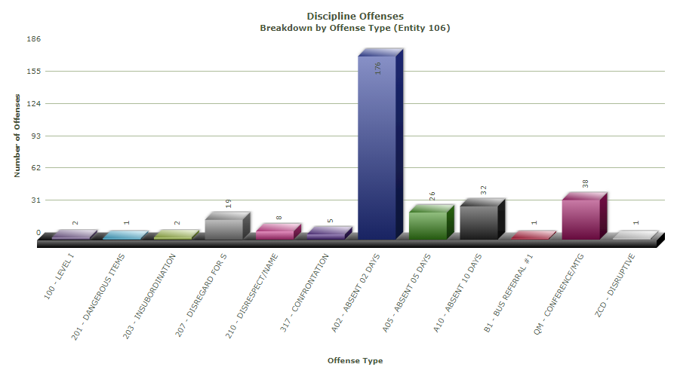  2019-20 School year  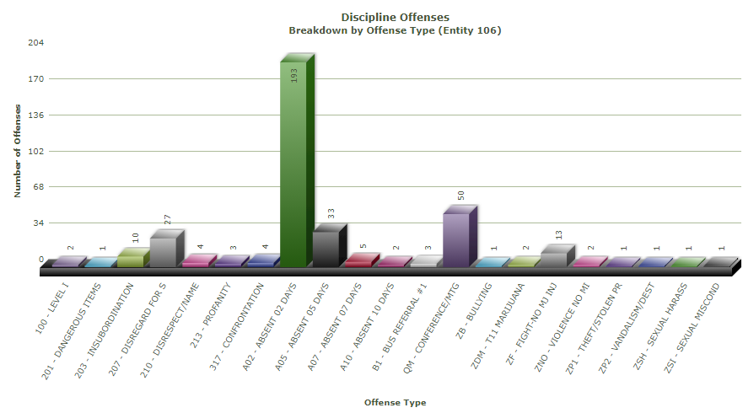  We had an overall decrease in major discipline behaviors. It was important to note, the 2020-21 school year consisted of a variety of in person and remote instruction.

SY 2020-2021 High-Priority Goal #3: By 2021, Kirkwood Elementary School will improve our student and family relationships as measured by school and community climate surveys.

Activities: Choose and describe two high-leverage activities implemented or tested related to achieving the stated high-priority goal above. | Measures: How did you analyze and evaluate? Please list and describe the tools you used to measure progress towards achieving your high-priority goal. Why were these tools appropriate? | Results/Progress: Please describe your results and progress so far in one to two sentences, i.e., what did you find in your data and what did it mean? (Paste hyperlinks in the space below to relevant documents if necessary.)
1)The COVID-19 pandemic caused us to pivot our focus from a school centered to home centered approach. Our interventions relied heavily on our outreach and support for families. We have conducted home visits, wellness checks, connectivity checks, delivered hotspots to families, and provided food directly to families. Staff have created video tutorials on how to log in, email, accessing school work, etc. Kirkwood Elementary sent home visitors out to provide tutorials on technology. | We used attendance records to measure student engagement. We identified three guiding questions to measure the effectiveness of our efforts: 1) Are outcomes equitable for all student groups?, 2) How big are the disparities?, 3) How much of your target group is affected by disproportionate chronic absenteeism? | We found that our largest disparities existed with our students who identified as American Indian/Alaskan Native. Of the 72 AI/AN students, 31.9% had 18 or more absences as of May 4, 2021. Students who identify as AI/AN are 1.85 times more likely than al other students to have 18+ absences. Based on our findings, we will focus our efforts towards addressing the disparities listed above.
2)Our CEE Data and climate surveys indicated that our school culture and climate was not conducive to a more connected school community at large that includes staff, students, and families. As a staff, we decided it would be best to focus on our staff SEL and student SEL. | We conducted two staff centered SEL survey and one student café to develop action steps for addressing this need. We found this valuable in order to keep a pulse of our overall climate especially through the constant change caused by COVID-19 precautions and efforts to provide a robust learning program. | Our staff wellness in reported a slight increase in positive feelings (happy, hopeful, and safe) and decrease in negative feelings (stressed, exhausted, frustrated, worried, and overwhelmed).  In the past week, how often did you feel ____ at work.  October 2020 May 2021  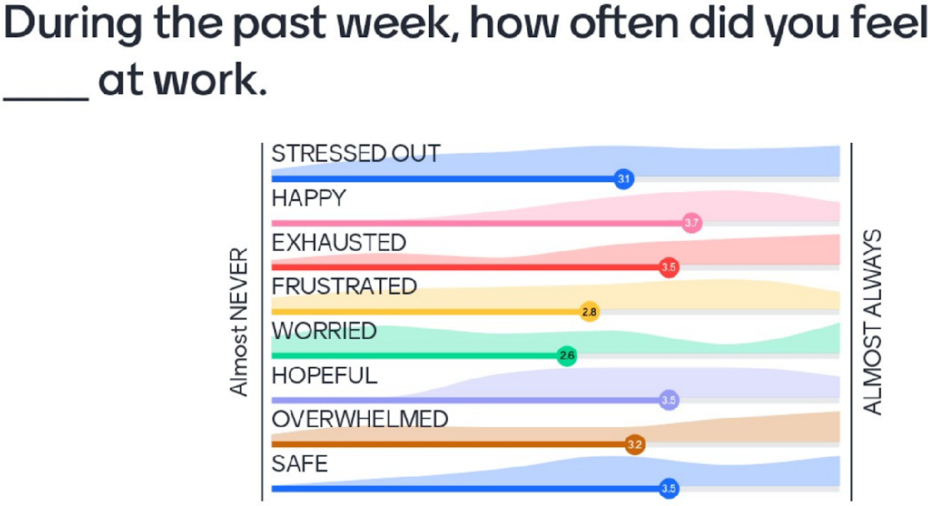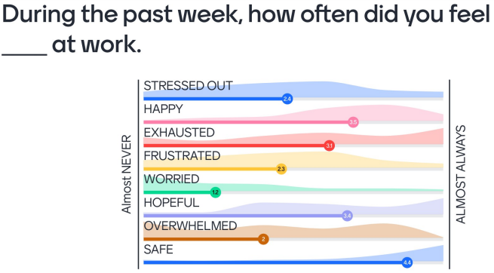  Our student café is scheduled for June 3, 2021.

Section II. 2020-21 End-of-Year Summary and Reflection Questions

The following Section is a summary reflection on end-of-year findings as documented in Section I above and to inform decision-making about 2021-2022 SIP Goals and Activities in Section III below. The purpose of these reflective and guiding questions is for building leadership to engage in practical and sustainable planning processes. Use of these questions and the additional Sections of this Template can encourage the formation of practical high-leverage goals and activities, progress monitoring using multiple indicators and measures, and data-informed adjustments within implementation cycles.
- In SY 2020-21, how have you responded to emerging student equity needs, particularly when it comes to eliminating opportunity gaps and supporting those students in your learning communities furthest from educational justice?
Our equity audit provided an in-depth view of the disparities which exist within our school community. Our efforts in addressing the emerging student equity needs included small group instruction in person, extending their school week on Fridays (Wildcat Academy), and home visits that provided delivery of essential items (food), instructional packets, technology support, and SEL. Furthermore, we continued to offer a hybrid model in order to provide a learning environment where our students and families felt safe.

- If Tribal consultation is applicable/required by ESSA Section 8538 in your district and building: How is your district engaging in timely, meaningful, and ongoing Tribal consultation in the planning and implementation of your SIP plan supporting AI/AN students, families, and communities?
There are three areas of collaboration between the Toppenish School District (TSD) and the Yakama Nation. One, is to implement the goals and recommendations of cultural and diverse curriculum content of Indian Education Parent Committees. Two, is implementation of a Tribal Liaison from the Yakama Nation Tribal Council Education Committee who has been a designated agenda speaker at monthly school board meetings. The Tribal Liaison provides updates of educational concerns, questions, calendar events, and any new tribal laws and policies. Lastly, there are two scheduled tribal consultation meetings; one in the fall and spring. These tribal consultation meetings provide a platform for TSD to present elementary and secondary AI/AN student data, primary focused areas of concentration within Indian Education, and take recommendations for the future development and focus of implementation of Indian Education within the overall school district

- Did you achieve any of your high-priority goals listed in Section I above? Describe what led to achieving that(/those) goal(s) or what prevented you from achieving it(/them).
Due to the pandemic, many of our goals were not achieved to the expected levels. However, gains were experienced in all three goals stated above. The changes that resulted from COVID-19 evolution affected many aspects. Instruction delivery (in-person, remote, and hybrid) required teachers to produce/modify instructional materials, the time in class restrictions shortened the school day to allow adequate time for disinfecting between Group A and Group B.

- How did at least one of the documented activities mentioned in Section I above (from SY 2020-21) positively impact student outcomes in relation to achieving its associated high-priority goal?
Our laser focused interventions and increased student to student dialogue resulted in an overall increase in student achievement despite the reduction of school hours and the limited in person instructional opportunities.

- What challenge(s) did you encounter this year with implementing activities for at least one high-priority goal?
Adjustments made to our schedule and limited opportunity for in-person interactions resulted in minimal opportunity to provide core instruction and interventions (goal 1) or family engagement (goal 3).

- What adjustments and modifications could be made towards addressing the challenge(s) detailed above for the upcoming academic year?
Our balanced calendar for next year will allow us to continue our interventions on Friday afternoons and eliminate Summer slide. Further professional development in PLC will allow us to enhance data informed instruction and interventions. We also recognized the need to continue our intervention program developed this year. The additional two Intervention Specialists and paraprofessional support will allow us to further provide the focused interventions that yielded great gains throughout the pandemic.

- What additional sources of data, if needed, will be collected to monitor the progress of those activities to be adjusted or modified?
We will need to continue to collect specific data on the continued effectiveness in interventions. This will allow us to pivot our interventions throughout the school year. In addition, we would like to have parent survey in the form of a parent café to gain a better understanding on how to engage our families.

Section III. OSPI School Improvement Plan for 2021-2022

Using the goals and activities, guiding questions, and planned adjustments detailed in Sections I and II above, please fill out the table below restating, reinterpreting or rewriting new SMARTIE Goals, associated activities, and budget allocations for SY 2021-22, incorporating any adjustments as necessary. Please refer to the OSSI SY 2020-2021 End-of-Year Review and SY 2021-2022 School Improvement Plan Template Implementation Guide for more details on examples of SMARTIE Goals, short- and long-term data sources that may be used in the “Measures” column for support, and other helpful planning aids.
Note: For schools operating a Title I, Part A, Targeted Assistance Program, indicate within your goals how you will address the needs of those students served to satisfy the appropriate Components.
SY 2021-22 SMARTIE Goal #1: By June 2022, Kirkwood Elementary will decrease the number of Tier III students for both ELA and Math by 10% according to I-Ready Diagnostics.
Activities  What evidenced-based practice will you implement and at or with whom is this activity aimed in order to achieve this goal? Describe two activities. | Timeframe  What is the projected length of time of the activity? | Lead  Who will be responsible for implementing, measuring and adjusting the activity? Who else will be involved? | Resources  What resources will be needed to implement this activity toward reaching the stated SMARTIE Goal (for example, professional development, extended time, curriculum, materials, etc.)? | Measures  What short- and long-term data will you collect to measure the impact of student learning and outcomes for the specific students named in your SMARTIE Goal?
1) PLC teams will use data cycles along with the MTSS framework to intentionally group students and identify interventions needed. | We will take a baseline measurement in August 2021 and a final measurement in June 2022 | We will collaborate with District Coaches and Curriculum Director. We will also work with independent consultants from iReady, Benchmark Universe, PLCs at Work, and Advanced Language Pedagogies. | We will need extended time to plan, prepare, and execute interventions. We will also need to purchase materials associated with the interventions to be applied. | We will use rubrics from the “Learning by doing” by DuFour to measure the effectiveness of our PLCs and identify areas for growth. Progress monitor tools and iReady diagnostic testing will be used to measure and analyze our Tiered percentages for long term data. WAKids data (Kindergarten), Oral Reading Records, and classroom based formative assessments will be used to determine short term growth data.
2)Hire two K-5 Certificated Intervention Specialist of 2FTE ($260,000). Intervention Specialists will plan and deliver PD to staff. They will work directly with Tier 2 and Tier 3 students, coordinate and lead training for support staff, and collect/analyze/present data to PLCs/MTSS/SIT teams. Intervention specialists will work closely with grade-level PLCs and inclusion specialists to create a coordinated effort to improve student learning. | The hired personnel will be with us for two years to address student needs and interventions. | We will monitor the effectiveness of the interventions using progress monitoring tools. Teachers and Intervention Specialist team will meet with the PLC regularly to plan/adjust and implement student interventions using a MTSS approach. | We will need extended time, professional development in Math and ELA best practices. Furthermore, we will need targeted materials to provide a robust intervention program. | We will collect specific data tied to the students’ intervention through the use of progress monitoring rubrics. For example, if Group A lacked High Frequency Words, then, we will collect data from our PreDDS or DDS to assess the students’ ability to read high-frequency words and sing/multi-syllable decodable words.
Funding amount and source(s) allocated to support activity (SY 2021-22 Expenditure linked to activity): Please list and describe funding source(s) associated with Activity 1 and Activity 2 above:
1) RAD-$40,000. Title I and LAP will support these activities. Specific allocations have not been determined.

2)RAD-$440,000 will pay for 2 paras and two intervention specialists. The other intervention specialist will be funded out of the ESSER budget.

SY 2021-22 SMARTIE Goal #2: By June 2022, Kirkwood Elementary will decrease the number of students receiving Tier III interventions by 15% as measured by ongoing data collection of building incident reports and PBIS Reward.
Activities  What evidenced-based practice will you implement and at or with whom is this activity aimed in order to achieve this goal? Describe two activities. | Timeframe  What is the projected length of time of the activity? | Lead  Who will be responsible for implementing, measuring and adjusting the activity? Who else will be involved? | Resources  What resources will be needed to implement this activity toward reaching the stated SMARTIE Goal (for example, professional development, extended time, curriculum, materials, etc.)? | Measures  What short- and long-term data will you collect to measure the impact of student learning and outcomes for the specific students named in your SMARTIE Goal?
1)Ongoing professional development in PBIS best practices identified through the use of a PBIS Tiered Fidelity Inventory Survey. | Throughout the 2021-2022 school year | We will seek out professional development from PBIS Rewards and other PBIS experts. | We will need professional development, extended time and purchase a tool for monitoring/analyzing student behaviors. | We will measure the effectiveness by analyzing the number of student incidents each quarter to determine the effectiveness of our PBIS implementation.  We will also conduct a PBIS TFIS at the end of the year.
2)Professional development in social emotional learning and implementation of school wide Tier I, II, and III. | The professional development will be ongoing throughout the 2021-22 school year. | District coaches and leading experts will provide professional development. Our staff will collect and report data. | We will need materials associated with SEL best practices and extended time to develop and analyze our effectiveness in meeting students’ SEL needs. | We will use ongoing classroom based assessments and rubrics to determine the effectiveness of our strategies.  We will also conduct a monthly data review of our incident reports.
Funding amount and source(s) allocated to support activity (SY 2021-22 Expenditure linked to activity): Please list and describe funding source(s) associated with Activity 1 and Activity 2 above:
1)RAD-$75,000 for timesheet, professional development, and supplemental materials. Title IV funds have been used to purchase the Character Strong curriculum and initial training.
2) RAD-$7,000. Title I funds will purchase PBIS Rewards.

SY 2021-22 SMARTIE Goal #3: By 2021, Kirkwood Elementary School will increase the positive interaction with our student and family relationships by 10% as measured by school and community climate surveys.
Activities  What evidenced-based practice will you implement and at or with whom is this activity aimed in order to achieve this goal? Describe two activities. | Timeframe  What is the projected length of time of the activity? | Lead  Who will be responsible for implementing, measuring and adjusting the activity? Who else will be involved? | Resources  What resources will be needed to implement this activity toward reaching the stated SMARTIE Goal (for example, professional development, extended time, curriculum, materials, etc.)? | Measures  What short- and long-term data will you collect to measure the impact of student learning and outcomes for the specific students named in your SMARTIE Goal?
1)Conduct student and parent climate surveys and community cafes. | We will conduct a parent cafe at the beginning of the year to establish action goals.  We will conduct student cafes in the Fall, Winter, and Spring to establish action plans. | Staff trained in facilitating community cafes will collect and report out the findings. Staff will be responsible for establishing and monitoring action plans. | We will need professional development and extended time to monitor and facilitate the community cafes. | We will measure the effectiveness of our action plans and progress through the use of climate surveys from the Fall and Spring.  Longitudinal data from the survey results will inform us of the effectiveness of using community cafes to address our students’ needs.
2) Establish a parent committee to determine family engagement nights that address their students’ needs. | The committee will be established in the fall and continue throughout the school year. | Building administration and district family liaisons will facilitate the committees. | We extended time for planning/preparation and hosting evening events. We will need to purchase materials related and light snacks. | We will use family surveys during family nights to determine if we are meeting their needs. We will keep a tally of who attends to determine how many families we engaged with throughout the year.
Funding amount and source(s) allocated to support activity (SY 2021-22 Expenditure linked to activity): Please list and describe funding source(s) associated with Activity 1 and Activity 2 above:
1)RAD - $15,000 . RAD money will be used for timesheets, light snacks and materials needed to run the community cafes.
2)RAD- $20,000 . Title I Parent Engagement Funds will be used for light snacks and materials to hand out to families to use at home to engage their children.

